Game Design document for shadows and alchemy

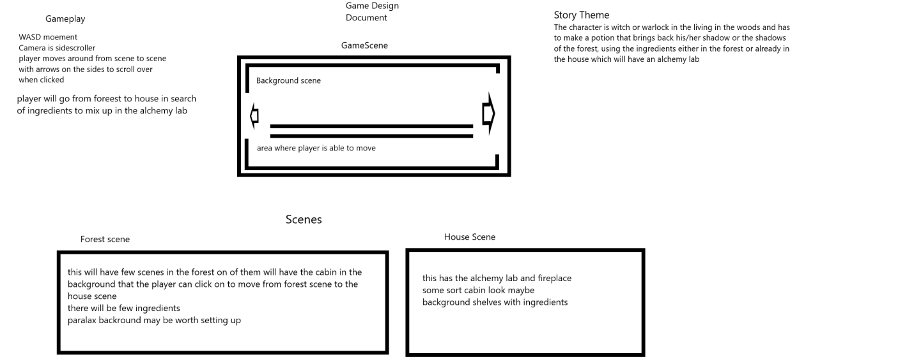

I am going to be making the moorlands as the theme instead of the forests, I want to have occasional rain.

Inside the house there is going to be player restricted to the stage area, I want to have a couldren where the ingredients are going to be mixed and maybe a pointlight on the fire below.

Outside is going to be parallax background with sky and thick clouds, the player will be able to move have just a bit of room to move left or right a bit and gather ingredients to mix in the couldran inside the house, for a potion to change him from being a shadow

Going to have a cave to have the mushrooms to be able to be picked.

Going to make cluuds that come by maybe some rain or thunder sounds

Player is going to collect ingredients for a potion that returns their shadow